19 reservoirs:

Ashokan Reservoir: 73 miles north of New York City, 122.9 billion gallons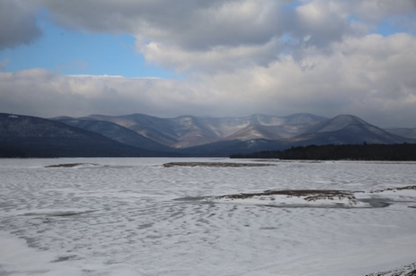

Boyds Corner Reservoir: 40 miles from New York City, 1.7 billion gallons

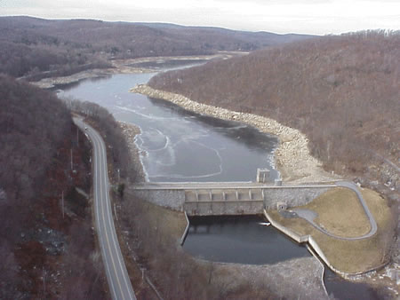

Cannonsville Reservoir: 120 miles northwest of New York City, 95.7 billion gallons

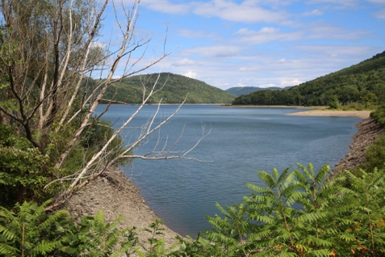

Kensico Reservoir: 15 miles north of New York City, 30.6 billion gallon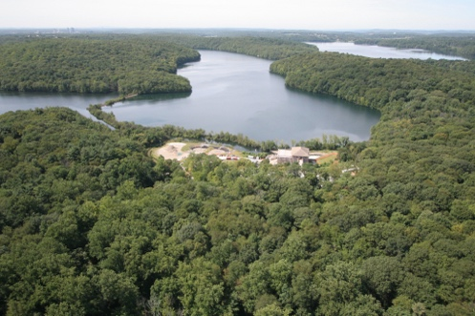

Neversink Reservoir: 75 miles from New York City, 34.9 billion gallons

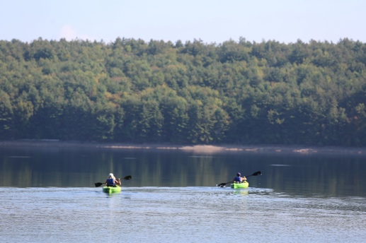

Pepacton Reservoir: 100 miles northwest of New York City, 140.2 billion gallons

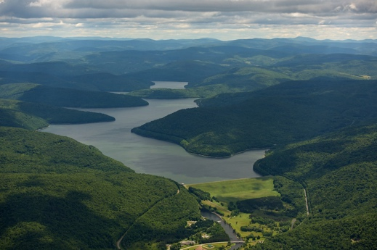

Rondout Reservoir: 65 miles northwest of New York City, 49.6 billion gallons

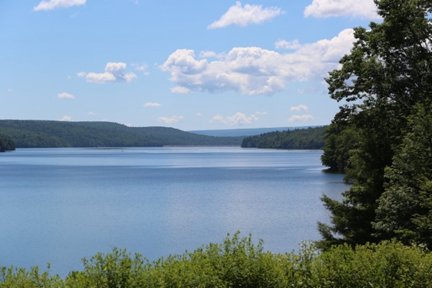

Schoharie Reservoir: 110 miles from New York City, 17.6 billion gallons

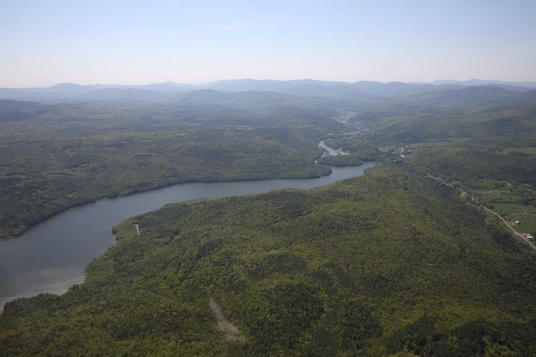

West Branch Reservoir: 35 miles from New York City, 8 billion gallons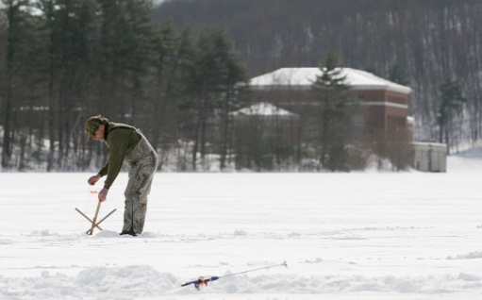

Amawalk Reservoir: 25 miles north of New York City, 6.7 billion gallons

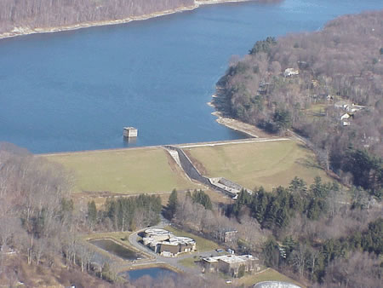

Bog Brook Reservoir: 38 miles from New York City, 4.4 billion gallons

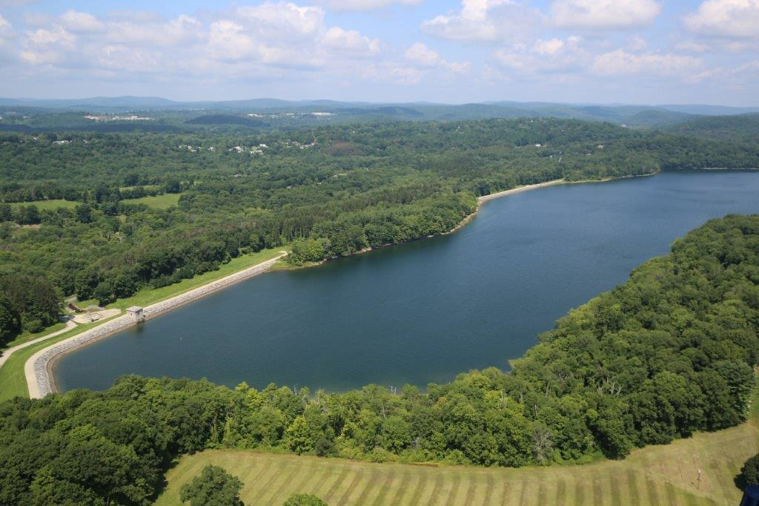

Cross River Reservoir: 25 miles from New York City, 10.3 billion gallons

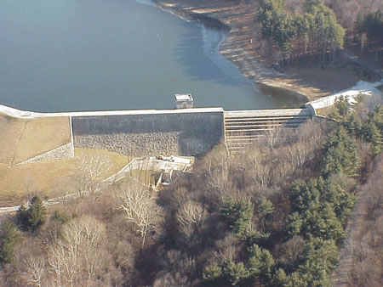

Croton Falls Reservoir: 30 miles north of New York City, 14.2 billion gallons

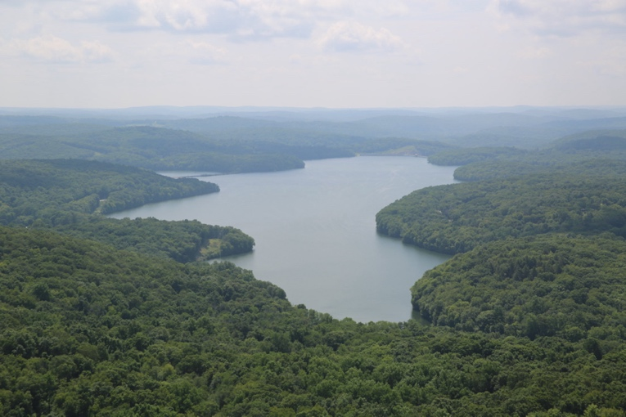

Diverting Reservoir: 35 miles from New York City, 900 million gallons

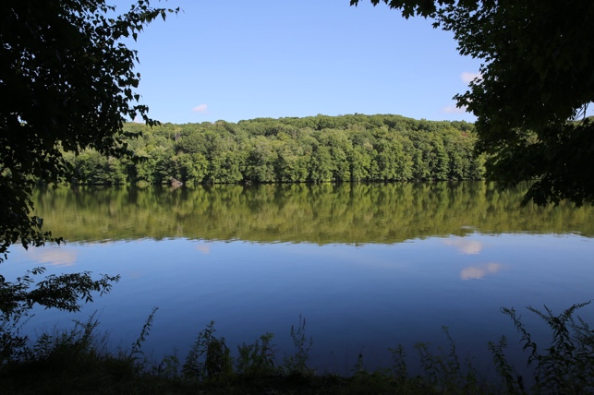

East Branch Reservoir: 35 miles north of New York City, 5.2 billion gallons

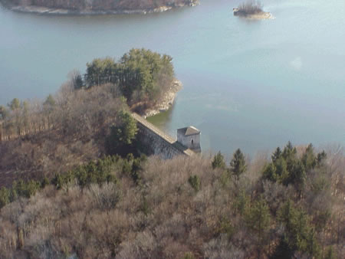

Middle Branch Reservoir: 35 miles from New York City, 4.1 billion gallons

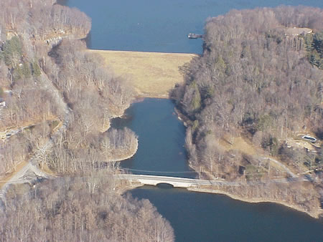

Muscoot Reservoir: 25 miles from New York City, 4.9 billion gallons

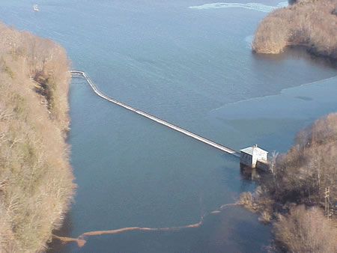

New Croton Reservoir: 22 miles from New York City, 19 billion gallons



Titicus Reservoir: 30 miles north of New York City, 7.2 billion gallons

